<!DOCTYPE html>

<html lang="en">

<head>

    <meta charset="UTF-8">

    <meta http-equiv="X-UA-Compatible" content="IE=edge">

    <meta name="viewport" content="width=device-width, initial-scale=1.0">

    <meta name="description" content="Zay E-Commerce">

    <!-- Google Fonts CDN -->

    <link rel="preconnect" href="https://fonts.googleapis.com">

    <link rel="preconnect" href="https://fonts.gstatic.com" crossorigin>

    <link href="https://fonts.googleapis.com/css2?family=Quicksand:wght@300&display=swap" rel="stylesheet">

    <!-- Icons CDN -->

    <link rel="stylesheet" href="https://cdnjs.cloudflare.com/ajax/libs/font-awesome/5.15.3/css/all.min.css" integrity="sha512-iBBXm8fW90+nuLcSKlbmrPcLa0OT92xO1BIsZ+ywDWZCvqsWgccV3gFoRBv0z+8dLJgyAHIhR35VZc2oM/gI1w==" crossorigin="anonymous" referrerpolicy="no-referrer" />

    <link href="https://fonts.googleapis.com/css2?family=Noto+Sans+JP:wght@900&family=Oswald:wght@700&family=Roboto+Condensed:wght@700&display=swap" rel="stylesheet">

    <!-- CSS Stylesheet CDN -->

    <link rel="stylesheet" href="css/main.css" type="text/css">

    <title>Zays E-Commerce</title>

</head>

<body>

    <!-- Top header -->

    <div class="topnav">

        <div class="topnav-left" style="margin-left: 5%;">

            <a href="#"><i class="fa fa-envelope" aria-hidden="true"></i> infor@company.com</a> &emsp;

            <a href="#"><i class="fa fa-phone" aria-hidden="true"></i> 010-020-0340</a>

        </div>

            <!-- socials -->

            <div class="topnav-right" style="margin-left: auto; margin-right: 2%;">

            <a href="#"><i class="fab fa-facebook-f"></i></a>

            <a href="#"><i class="fab fa-instagram"></i></a>

            <a href="#"><i class="fab fa-twitter"></i></a>

            <a href="#"><i class="fab fa-linkedin"></i></a>

            </div>

    </div>

    <!-- Navigation bar -->

    <div class="nav">

            <a href="#" class="logo">Zay</a>

            <a href="#" style="flex-grow: 1;">Home</a>

            <a href="#"style="flex-grow: 1;">About</a>

            <a href="#"style="flex-grow: 1;">Shop</a>

            <a href="#"style="flex-grow: 1;">Contact</a>

            <div class="nav-left">

                <a href="#" id="search1"><i class="fa fa-search" aria-hidden="true"></i></a>

                <a href="#"><i class="fa fa-cart-arrow-down" aria-hidden="true"></i></a>

                <a href="#"><i class="fa fa-user" aria-hidden="true"></i></a>

            </div>

    </div>

    <!-- Main Content 1st block -->

    <div class="main-top">

        <img src="image/curology.png" alt="1st">

        <div class="info1">

            <span class="first-font"> Prodient Occaecat</span><br>

            <span class="second-font">Aliquip ex ea commodo consequat</span><br> <br>

            <span class="third-font"> Your are permitted to use this Zay CSS template for your <br> commercial websites.

             You are <b>not permitted</b> to re-distribuite <br> the template ZIP file in any kind of template collection website</span>

        </div>

    </div>

    <!-- Main Content 2nd block -->

    <div class="heading">

        <span class="first-font">Categories of the Month</span> <br>

        <span class="third-font">Excepteur sint occaecat cupidatat non proident, sunt in culpa qui <br>officia deserunt mollit anim id est lalorum</span>

    </div>

        <div class="mid-main">

            <!-- 1st product -->

            <div class="first-product">

                    <img src="image/watch.jpg" alt="watch" width="100%" id="offer">

                    <p class="second-font" id="text-watch">Watches</p>

                    <button class="glass">Shop now</button>

            </div>

            <!-- 2nd product -->

            <div class="second-product">

                    <img src="image/shoes.jpg" alt="watch" width="100%" id="offer">

                    <p class="second-font" id="text-watch">Shoes</p>

                    <button class="glass">Shop now</button>

            </div>

            <!-- 3rd product -->

            <div class="third-product">

                    <img src="image/sunglasses.jpg" width="100%" alt="watch" id="offer">

                        <p class="second-font" id="text-watch">Accessories</p>

                            <button class="glass">Shop now</button>

             </div>

        </div>

        <!-- Main Content 3rd block -->

        <div class="end-main">

            <div class="heading2" style="text-align: center;">

            <span class="first-font">Featured Product</span>

            <p class="third-font" style="margin-top: 0px;">Reprehenderit in voluptate velit esse cillum dolore eu fugiat nulla <br> pariatur. Excepteur sint occaecat cupidatat non proident</p>

            </div>

            <!-- Cards -->

            <div class="features">

                <!-- Card 1 -->

               <div class="card1">

                   <img src="image/light.jpg" alt="light" width="100%"style="margin-bottom: 0;">

                   <div class="padding1">

                       <span>

                    <i class="fas fa-star" style="color: gold;"></i><i class="fas fa-star" style="color: gold;"></i><i class="fas fa-star" style="color: gold;"></i><i class="fas fa-star" style="color: grey;"></i><i class="fas fa-star" style="color: grey;"></i>

                     <span style="margin-left: 200px;"> $250.00</span></span>

                    <br>

                    <br>

                    <span class="second-font" style="text-align: center; margin-top: 20px;">Gym Weight</span><br>

                    <span class="third-font">Lorem ipsum dolor sit amet, <br> consectetur adipisicing elit. sunt in <br> culpa qui officia deserunt</span>

                    <br><br><br>

                     <span>Reviews(24)</span>

                   </div>

               </div>

               <!-- Card 2 -->

                <div class="card2">

                    <img src="image/watchcard.jpg" alt="light" width="100%"style="margin-bottom: 0;">

                    <div class="padding2">

                    <span>

                    <i class="fas fa-star" style="color: gold;"></i><i class="fas fa-star" style="color: gold;"></i><i class="fas fa-star" style="color: gold;"></i><i class="fas fa-star" style="color: grey;"></i><i class="fas fa-star" style="color: grey;"></i>

                    <span style="margin-left: 220px;"> $480.00</span></span>

                    <br>

                    <br>

                    <span class="second-font" style="text-align: center; margin-top: 20px;">Cloud Nike Shoes</span><br>

                     <span class="third-font">Aenean gravida dignissim finibus <br> Nullam ipsum diam, posuere vitae <br>pharetra sed, commodo ullamcorper</span>

                     <br><br>

                     <span>Reviews(48)</span>

                    </div>

                 </div>

                 <!-- Card 3 -->

                 <div class="card3">

                    <img src="image/camera.jpg" alt="light" width="100%"style="margin-bottom: 0;">

                    <div class="padding3">

                    <span>

                    <i class="fas fa-star" style="color: gold;"></i><i class="fas fa-star" style="color: gold;"></i><i class="fas fa-star" style="color: gold;"></i><i class="fas fa-star" style="color: gold;"></i><i class="fas fa-star" style="color: gold;"></i>

                    <span style="margin-left: 220px;"> $360.00</span></span>

                    <br>

                    <br>

                    <span class="second-font" style="text-align: center; margin-top: 20px;">Summer Addides Shoes</span><br>

                     <span class="third-font">Curabitur ac mi sit amet diam luctus porta.phasellus pulvinar sagittis diam, et scelerisque ipsum lobrtis nec.</span>

                     <br><br>

                     <span>Reviews(74)</span>

                    </div>

                 </div>

            </div>

        </div>

        <!-- Footer 1st Block -->

        <div class="top-footer">

            <span class="second-font" style="color:#5AC87F; font-family: 'Roboto Condensed', sans-serif; ">Zay Shop</span> <span class="second-font">Product</span> <span class="second-font"> Future Info</span>

            <p style="grid-row: 3 / 4;"><i class="fas fa-map-marker-alt"></i> &emsp; 123 consectetur at ligula 10660</p>

            <p style="grid-row: 4 / 5;"><i class="fa fa-phone" aria-hidden="true"></i> &emsp;010-020-0340</p>

            <p style="grid-row: 5 / 6;"><i class="fa fa-envelope" aria-hidden="true"></i> &emsp; infor@company.com</p>

            <p style="grid-row: 3 / 4; grid-column: 2 / 3;">Luxury</p>

            <p style="grid-row: 4 / 5; grid-column: 2 / 3;">Sport Wear</p>

            <p style="grid-row: 5 / 6; grid-column: 2 / 3;">Men's Shoes</p>

            <p style="grid-row: 6 / 7; grid-column: 2 / 3;">Womens's Shoes</p>

            <p style="grid-row: 7 / 8; grid-column: 2 / 3;">Popluar Dress</p>

            <p style="grid-row: 8 / 9; grid-column: 2 / 3;">Gym Accessories</p>

            <p style="grid-row: 9 / 10; grid-column: 2 / 3;">Sprots Soes</p>

            <p style="grid-row: 3 / 4; grid-column: 3 / 4;">Home</p>

            <p style="grid-row: 4 / 5; grid-column: 3 / 4;">About Us</p>

            <p style="grid-row: 5 / 6; grid-column: 3 / 4;">Shop Locations</p>

            <p style="grid-row: 6 / 7; grid-column: 3 / 4;">FAQs</p>

            <p style="grid-row: 7 / 8; grid-column: 3 / 4;">Contact</p>

        </div>

        <!-- Socials Footer 2nd Block -->

    <div class="footer">

        <a href="#"><i class="fab fa-facebook-f"></i></a>

        <a href="#"><i class="fab fa-instagram"></i></a>

        <a href="#"><i class="fab fa-twitter"></i></a>

        <a href="#"><i class="fab fa-linkedin"></i></a>

        <input type="email" name="email" id="email" placeholder="Email Address" style="margin-left: auto;"> <input type="submit" value="Subscribe">

    </div>

    <!-- Footer 3rd Block -->

    <div class="footer-end">

        <p style="margin-left: 50px;">Copyright &copy; 2021 Company Name | Designied by <u> Adeeb Shah</u></p>

    </div>

</body>

</html>

**Main.css**

body{

    box-sizing: border-box;

    font-family: 'Quicksand', sans-serif;

}

/* Navigation */

.topnav{

    background-color: #242C41;

    padding: 15px;

    display: flex;

}

.topnav-right a{

    margin-right: 8px;

}

a{

    text-decoration: none;

}

a:link{

    color: white;

}

.topnav a:visited{

    color: white;

}

.topnav a:link{

    color: white;

}

.nav{

    padding: 10px;

    display: flex;

    align-items: center;

}

.nav .logo{

    flex-grow: 1;

    font-size: 50px;

    text-decoration: none;

    font-family: 'Roboto Condensed', sans-serif;

    margin-left: 5%;

}

.nav .logo:visited{

    color: #5AC87F;

}

.nav .logo:link{

    color: #5AC87F;

}

.nav a{

    padding: 10px;

    font-size: 20px;

}

.nav a:visited{

    color: black;

}

.nav a:link{

    color: black;

}

.nav-left{

    flex-grow: 1;

    align-self: center;

    display: inline-block;

}

/* Main  */

.main-top{

    display: grid;

    grid-template-columns: repeat(15, 1fr);

    grid-template-rows: repeat(13, 50px);

    max-width: 100%;

}

img[alt="1st"]{

    height: 90%;

    width: 100%;

    grid-column: 1 / 16;

    grid-row: 1 / 15;

    display: block;

}

.info1{

    grid-column: 2 / 12;

    grid-row: 5 / 8;

    align-self: start;

    overflow: hidden;

}

.first-font{

    font-size: 70px;

    font-weight: -10;

}

.second-font{

    font-size: 40px;

    font-weight: bolder;

}

.third-font{

    font-size: 25px;

}

.heading{

    text-align: center;

}

#offer{

    border-radius: 50%;

    display: block;

    margin-left: 50px;

}

.mid-main{

    display: flex;

    justify-content: space-evenly;

    flex-wrap: wrap;

    margin-top: 10px;

    align-content: center;

    margin-top: 50px;

    margin-bottom: 80px;

}

.first-product, .second-product, .third-product{

    max-width: 500px;

    margin-bottom: 50px;

}

img[alt="watch"]{

    width: 350px;

    height: 300px;

    padding-right: 50px;

    border-radius: 50%;

}

#text-watch{

    font-size: 30px;

    text-align: center;

}

.glass{

    margin-left: 180px;

    background-color: #4CAF50;

    border: none;

    color: white;

    text-align: center;

    text-decoration: none;

    font-size: 16px;

    cursor: pointer;

    border-radius: 8px;

    width: 115px;

    height: 45px;

}

.features{

    margin-left: 2%;

    margin-top: 2%;

    padding-top: 30px;

    display: flex;

    justify-content: space-evenly;

    flex-wrap: wrap;

}

.card1{

    box-shadow: 0 4px 8px 0 rgba(0,0,0,0.2);

    transition: 0.3s;

    border-radius: 5px;

    width: 430px;

    margin-bottom: 20px;

}

.padding1{

    background-color: white;

    padding: 6.8% ;

    padding-bottom: 32px;

}

.card2{

    box-shadow: 0 4px 8px 0 rgba(0,0,0,0.2);

    transition: 0.3s;

    border-radius: 5px;

    width: 430px;

    margin-bottom: 20px;

}

.padding2{

    background-color: white;

    padding: 6.56% ;

}

.card3{

    box-shadow: 0 4px 5px 0 rgba(0,0,0,0.2);

    transition: 0.3s;

    border-radius: 5px;

    width: 430px;

}

.padding3{

    background-color: white;

    padding: 4.9%

}

/* Footer */

.top-footer{

    display: grid;

    background-color: #253143 ;

    padding: 70px;

    grid-template-columns: auto auto auto;

    grid-template-rows: 50px 25px 40px 40px 40px 40px 40px 40px 40px;

    column-gap: 25px;

    color: white;

}

.footer{

    background-color: #253143;

    display: flex;

    padding-left: 6%;

    padding-right: 6%;

    padding-bottom: 50px;

}

.footer a{

    font-size: 30px;

    margin-right: 5%;

}

.footer a:visited{

    color: white;

}

input[value="Subscribe"]{

    width: 100px;

    color: white;

    background-color:#4CAF50;

    border: none;

    border-radius: 0 5px 5px 0;

    margin-left: -5px;

}

input[type=email]{

    width: 230px;

    background-color: transparent;

    border: 0.5px solid grey;

    border-radius: 5px;

}

.footer-end{

    background-color: #1C2532;

    padding: 20px;

    color: white;

}

/* Media Qurey for Tablet */

@media only screen and (max-width: 980px){

    .info1{

        grid-row: 2 / 8;

    }

    .info1 .first-font{

        font-size: 50px;

    }

}

/* Media Qurey for Mobile */

@media only screen and (max-width:700px){

    .nav{

        flex-direction: column;

    }

    .nav a{

        margin-bottom: 20px;

    }

    #search1{

        justify-content: center;

        margin-left: 0;

    }

}

**Output – desktop**

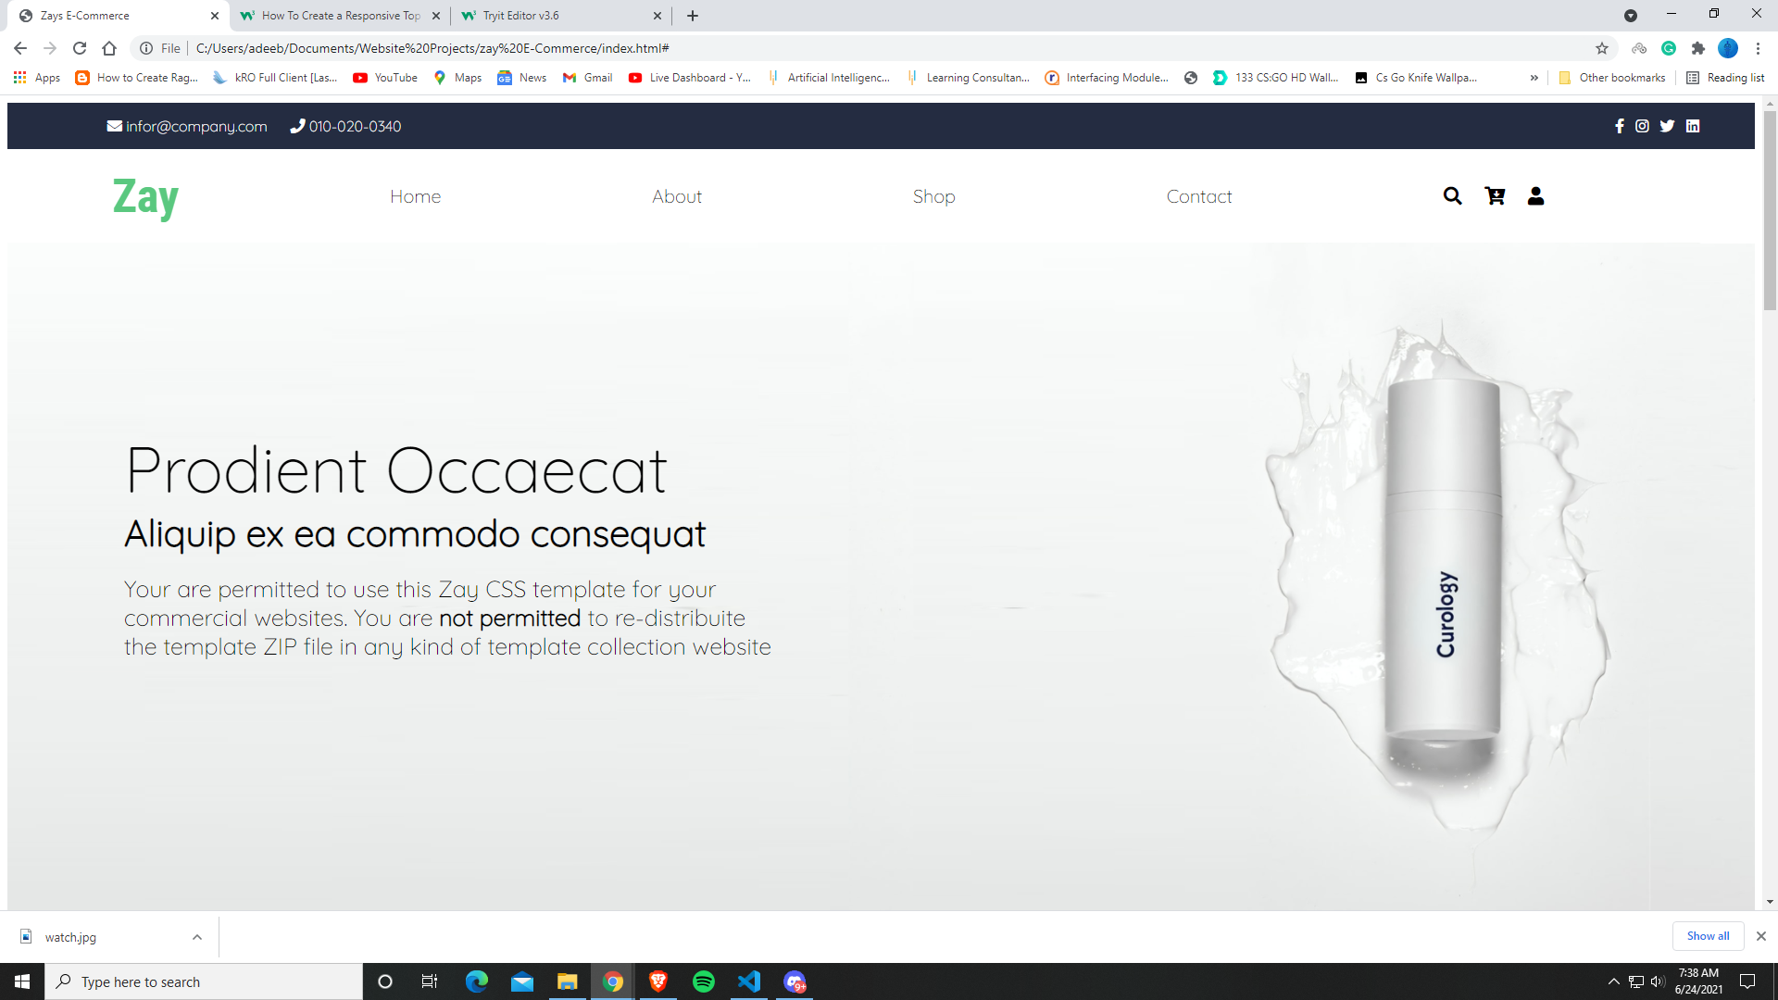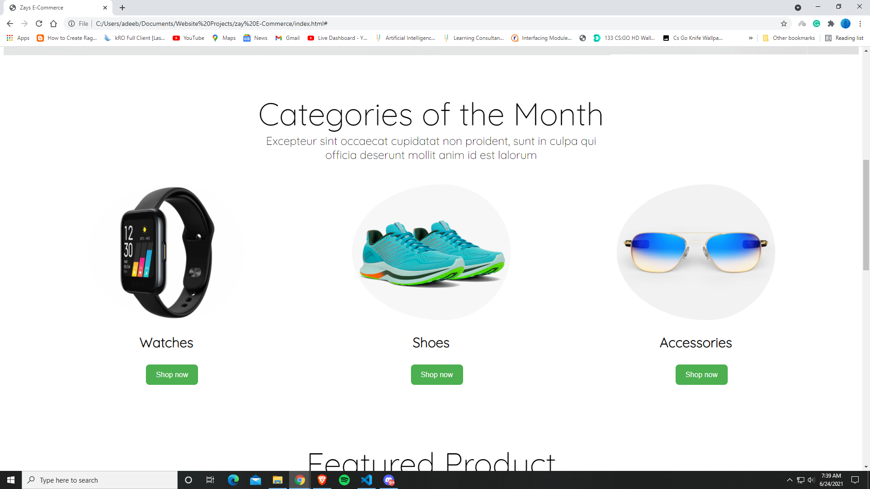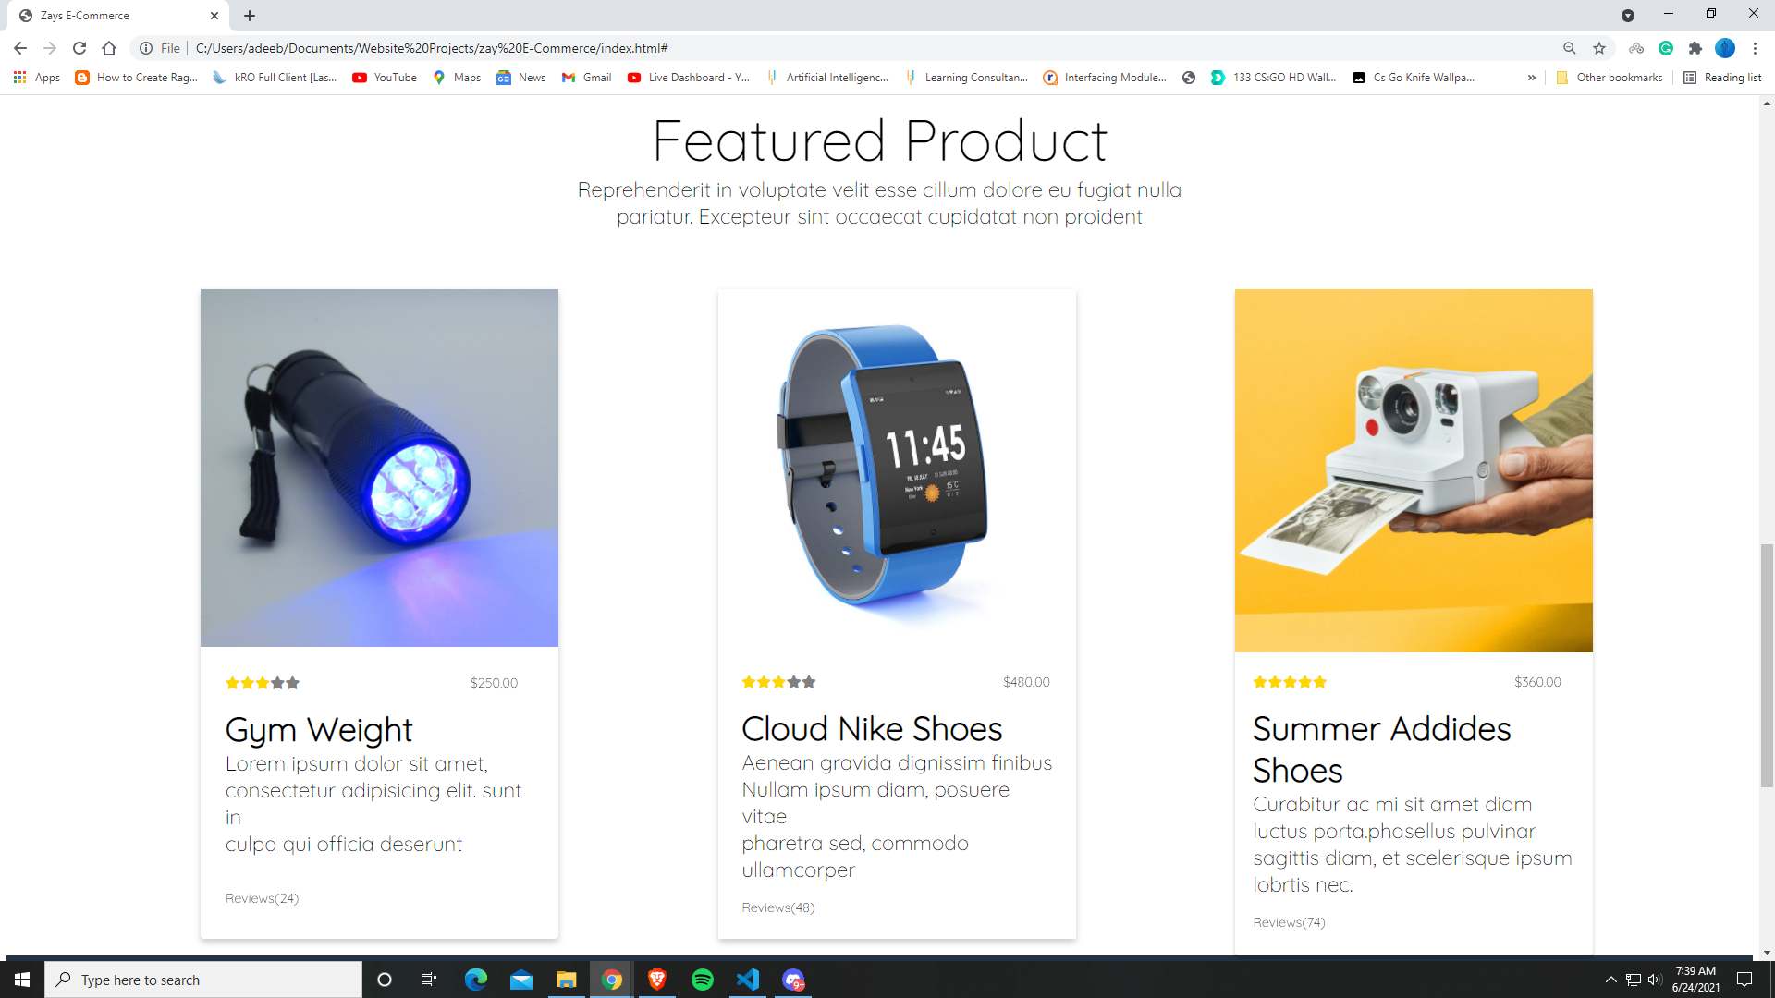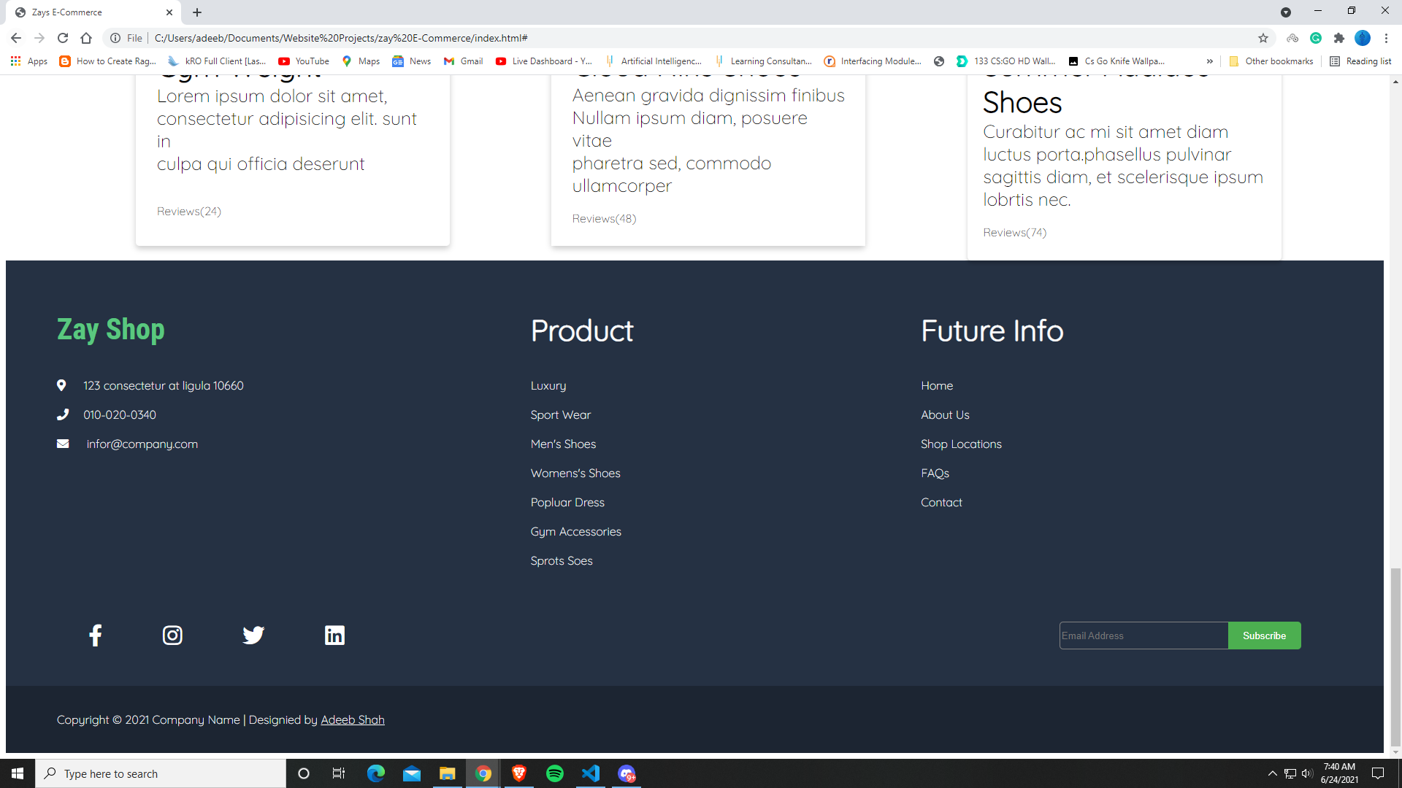

**Tablet –**

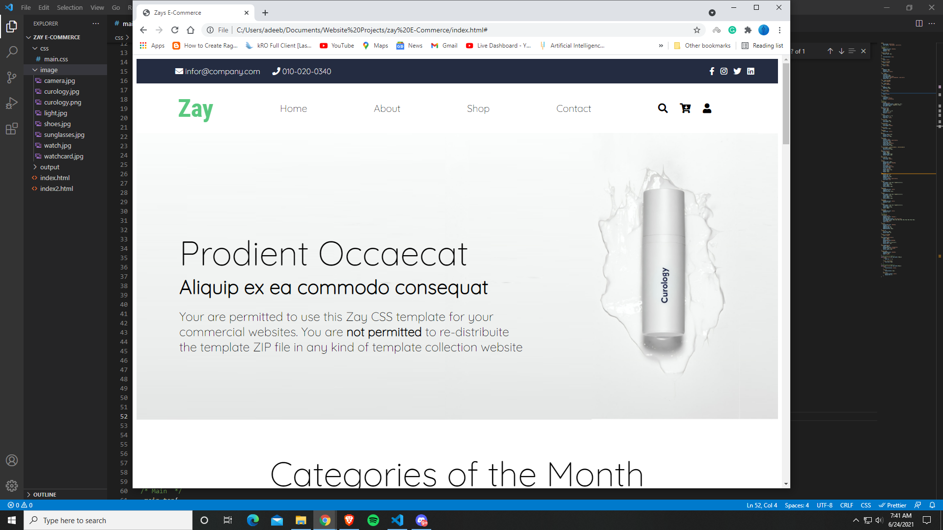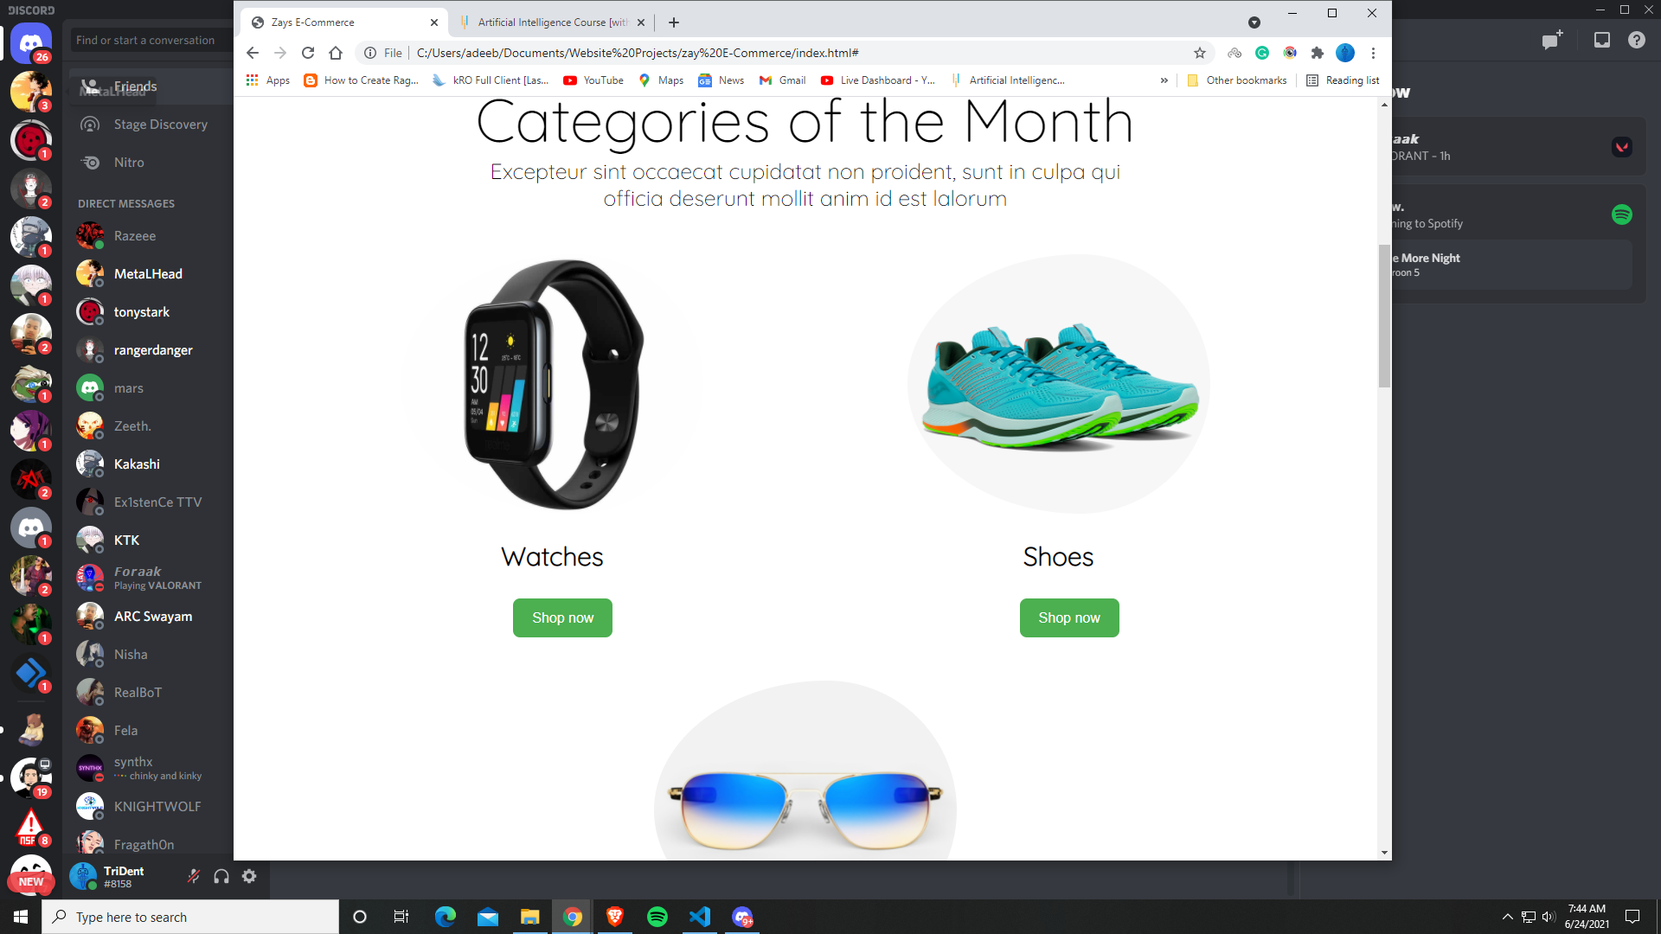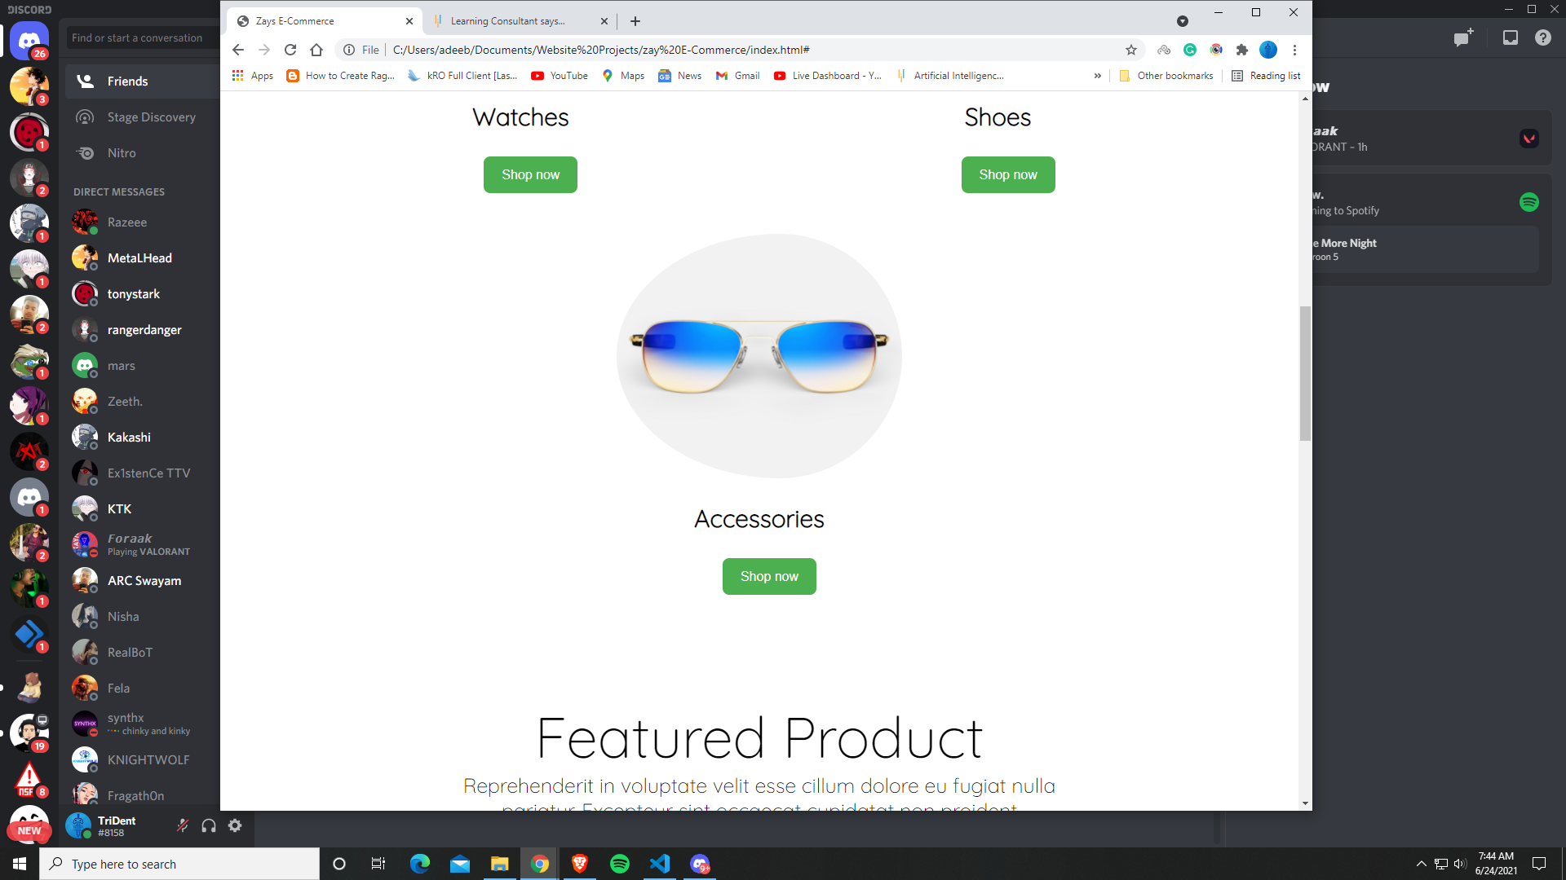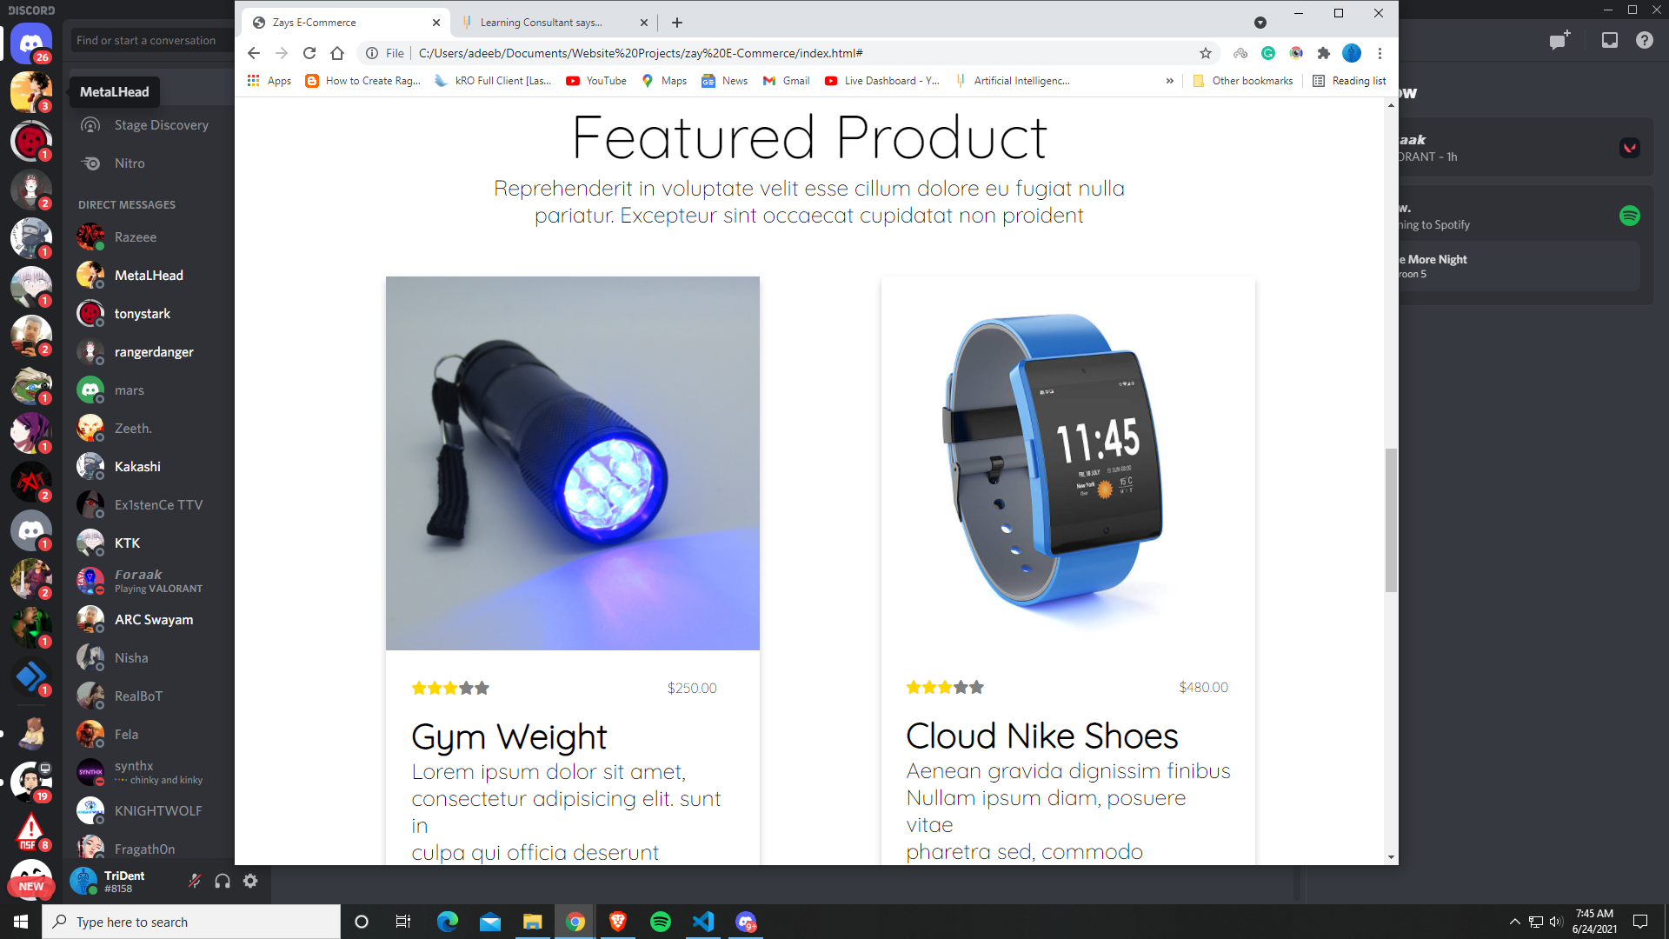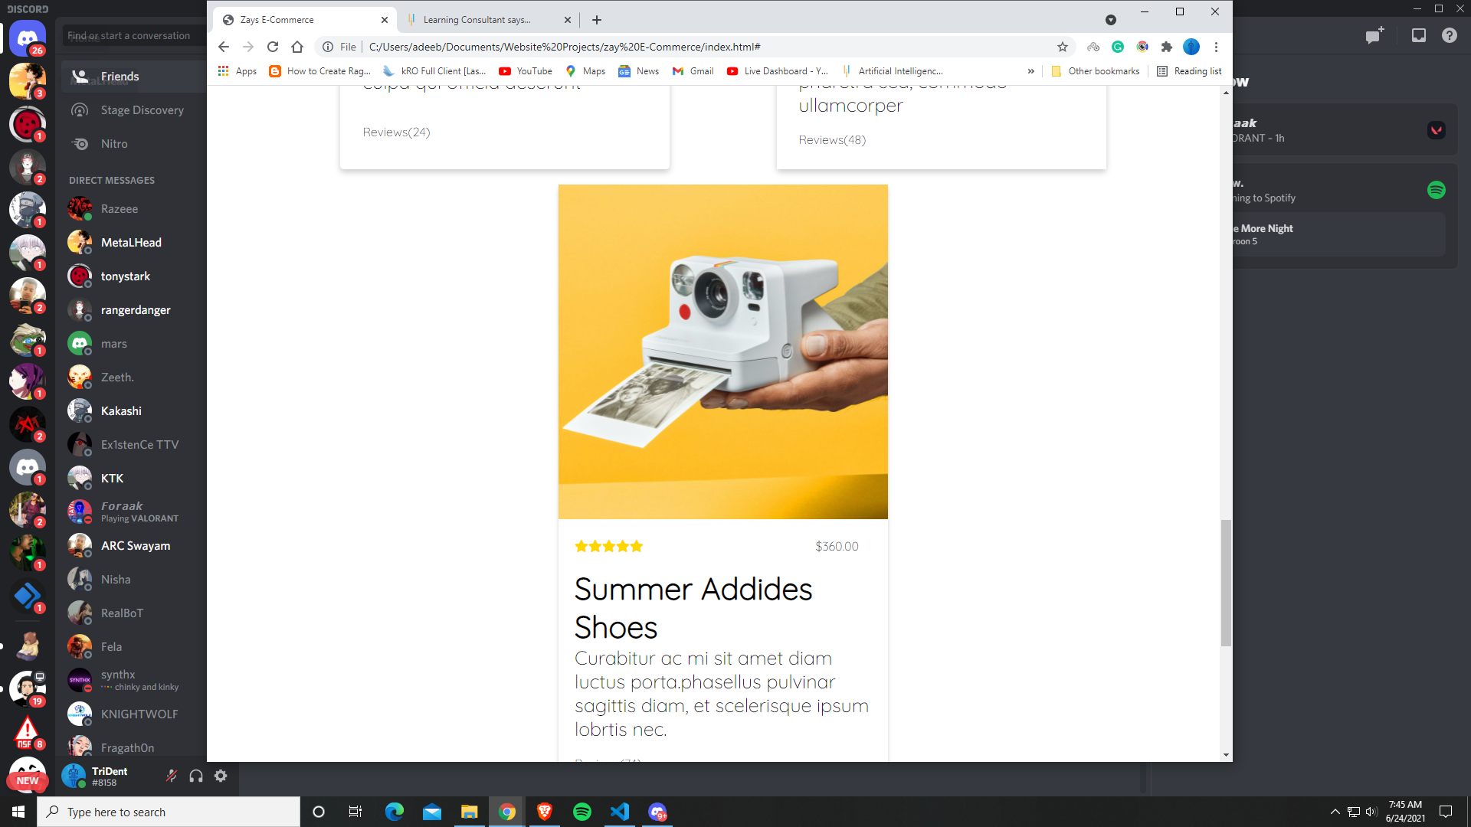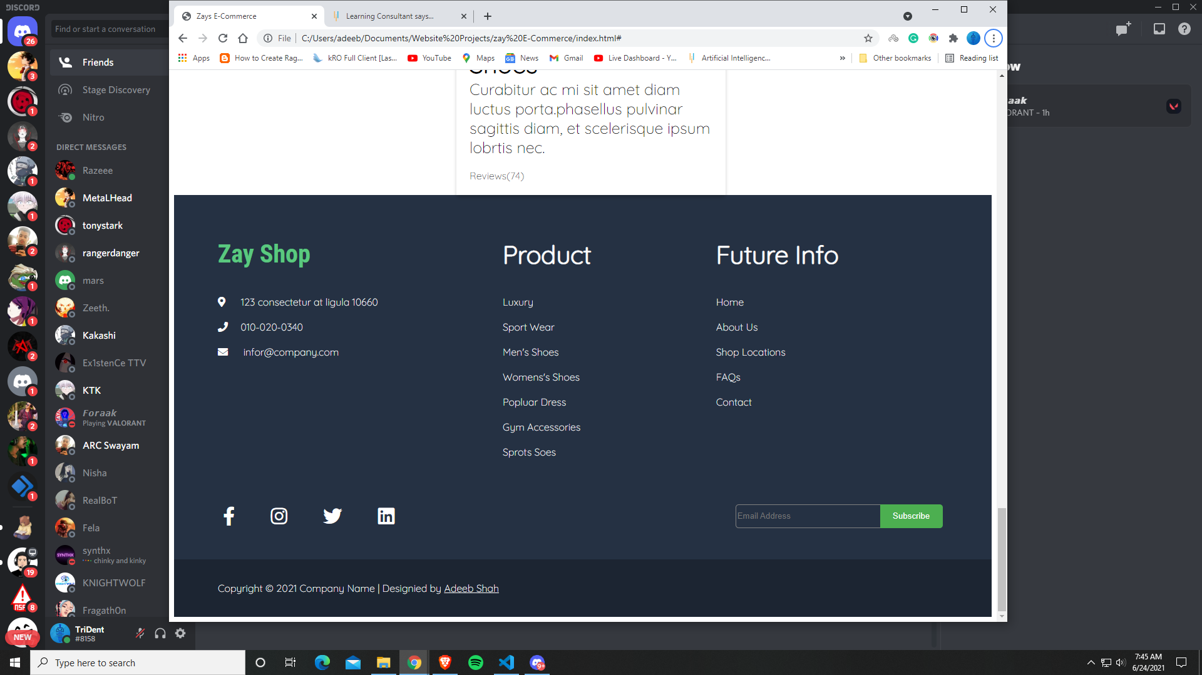

**Mobile –**



